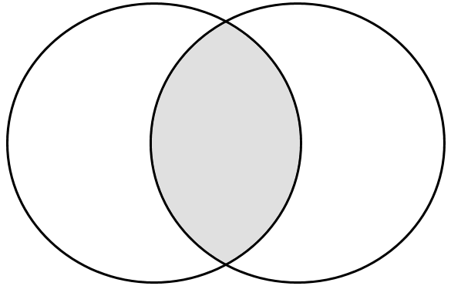

**Ptolemaic Universe**

**Copernican Universe**

Summary statement using the terms *geocentric, heliocentric, elliptical*: