The Zimmerman Telegram
In early 1917, British cryptographers were surprised when a encoded German transmission came across their desks. These experts were able to decipher the message, and in doing so changed history more than any other cryptographer, past or present.
The Zimmerman telegram was a secret communication from German Foreign Minister Arthur Zimmerman to the German Minister to Mexico, von Eckhardt. It contained an offer of US territory for Mexico, if it joined the German cause.
Until that point, the United States had tried to remain neutral in World War I. However, the British and other allies were begging and pleading for help. Attitudes in the US were shifting towards war, and the telegram acted as a catalyst. The British capitalized on that attitude, and in a politically smart move, they showed the United States the telegram on February 24, 1917.
The United States published the telegram, making the public aware of it on March 1. The public opinion quickly became a definite pro-war. Congress officially declared war against Germany and its allies on April 6, 1917.
Here is a picture of the telegram as it was received, encoded:
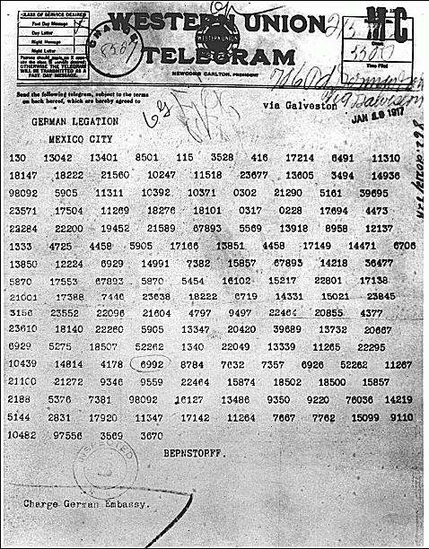
This is a picture of the same telegram, but decoded:
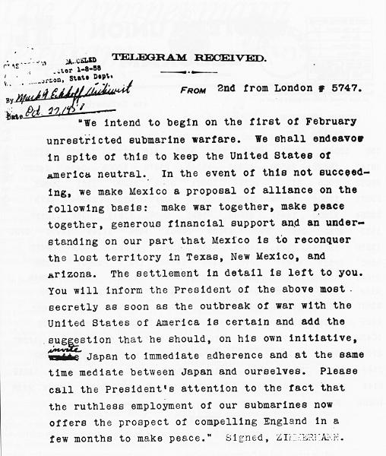
These two images are in the public domain. They were obtained from the National Archives and Records Administration

