During the Middle Ages, diagnosis was also influenced by astrology. Medical charts informed physicians what not to do for people born under a certain start sign.
Aries | Avoid incisions in the head and face and cut no vein in the head.
Taurus | Avoid incisions in the neck and throat and cut no veins there.
Gemini | Avoid incisions in the shoulders, arms or hands and cut no vein.
Cancer | Avoid incisions in the breasts, sides, stomach and lungs and cut no vein that goes to the spleen.
Leo | Avoid incisions of the nerves, lesions of the sides and bones, and do not cut the back either by opening and bleeding.
Virgo | Avoid opening a wound in the belly and in the internal parts.
Libra | Avoid opening wounds in the umbellicus and parts of the belly and do not open a vein in the back or do cupping.
Scorpio | Avoid cutting the testicles and anus.
Sagittarius | Avoid incisions in the thighs and fingers and do not cut blemishes and growths.
Capricorn | Avoid cutting the knees or the veins and sinews in these places.
Aquarius | Avoid cutting the knees or the veins and veins in these places.
Pisces | Avoid cutting the feet.
History Learning Site: Medicine in the Middle Ages
http://www.historylearningsite.co.uk/
http://www.historylearningsite.co.uk/medicine_in_the_middle_ages.htm 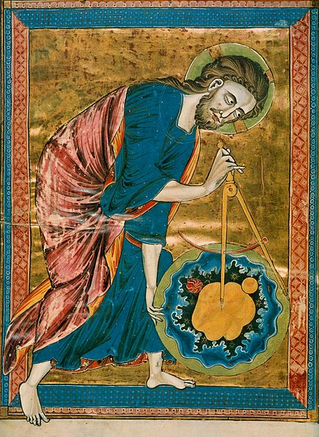
Science, and particularly geometry and astronomy/astrology, was linked directly to the divine for most medieval scholars. The compass in this 13th century manuscript is a symbol of God's act of Creation. God has created the universe after geometric and harmonic principles, to seek these principles was therefore to seek and worship God.
- Title: God as Architect/Builder/Geometer/Craftsman
- From: The Frontispiece of Bible Moralisee
- Style: Gothic
- Date: mid-13th C.
- Location: France
- Codex Vindobonensis 2554 (French, ca. 1250), in the Österreichische Nationalbibliothek.

