WORLD HISTORY MIDTERM REVIEW

- Why did Jews reject Roman control even though they were allowed to worship freely? Infer how the rise of Christianity may have led to the fall of the Roman Empire?
INFER | Read between the lines | 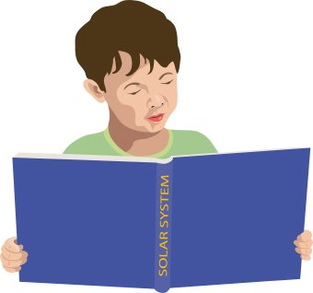

- Evaluate the importance of the printing press to Martin Luther? How did it help him achieve his goals?
EVALUATE | Judge

- Support the period of 1300-1500 being called the Renaissance in Western Europe. Use the terms humanism, secular, and religious. Also include examples of art (paintings, sculptures, architecture)
SUPPORT | Back up with details

- Trace the events that led to the weakening of the Roman Catholic Church. Include the terms protestant, 95 Thesis, Martin Luther, indulgences, Council of Trent, and reform.
TRACE | List in steps

- Summarize what was exchanged during the Colombian Exchange. Use the term cultural diffusion.
SUMMARIZE | Give short version

- What was the goal or purpose of the Crusades? Describe the impact the Crusades had on:
- Economy/trade
- Relationship among religious groups
- Cultural diffusion
- Urban Centers/cities
- The onset of the Renaissance
DESCRIBE | Tell all about

- Analyze the causes and effects of global exploration on the new world.
ANALYZE | Break apart

- Identify each text as religious or secular. Explain the effect of each on human behavior.
- Vedas
- Magna Carta
- Hammurabi’s Code
- Torah
- The Prince
EXPLAIN | Tell how

